**OCMS 43 – Payment Processing**

**Prepared** **by**



MGG **SOFTWARE**

**Version History**

|  |  |  |  |
| --- | --- | --- | --- |
| **Version** | **Updated By** | **Date** | **Changes** |
| v1.0 | Rafif | 01/05/2025 | Document Initiation |
| v1.1. | Rafif | 12/08/2025 | * Restructure the Table of content * Add payment status back * Revise flow sync intranet to internet and Internet to Intranet * Add new section about AXS |
| v1.2 | Rafif | 26/08/2025 | * Section 1.6: Add section for end day check sync notice * Section 2.4: Revise flow payment matrix |
| v1.3 | Danu, Rafif | 23/09/2025 | * Section 1.5: Modify flow only need to check notice that not sync yet * Section 2 Update flow and add new table ocms_refund_notice * Section 3 Change to use ocms_refund_notice * Move section 2 and 3 to OCMS 50 * Move section 5 to OCMS 44 |
| v1.4 | Rafif | 30/10/2025 | * add scenario for intranet push data to internet * removing refund_identified_date in VON * add more detail information feilds for cron pull internet |
| v1.5 | Mubi, Rafif | 11/11/2025 | * Add rollback mechanism for WTD (Web Transaction Detail) sync operations * Convert to batch queries for VON operations (no per-record looping) * Split INSERT and UPDATE flows into separate pathways * Add upsert logic: If notice exists in Internet → UPDATE; otherwise → INSERT * Move intranet to internet sync to cron jobs if no need immediately update * Remove addr table to sync to internet * Only update important field to internet * Change Generate Paid Notices Report for URA Finance use ocms_refund_notice * Toppan sync to internet add last_processing_stage, next_processing_stage, eservice_message and payment_acceptance_allowed * Remove Failed eNotification flow scenario |
| v1.6 | Rafif | 15/11/2025 | * Section 2.3: Update flow cron pull internet to intranet |
| v1.6.1 | Rafif | 04/12/2025 | Section 2:   * Add is_sync to eVON * Add check double pay for PS-FP/PS-PRA * Update refund notice table |

**Table of Content**

|  |  |  |  |  |  |  |  |  |  |  |  |  |
| --- | --- | --- | --- | --- | --- | --- | --- | --- | --- | --- | --- | --- |
| **Section** | | | | **Content** | | | | | | | | **Pages** |
| 1 | | | | Sync Offence Notice and Offender data between the Intranet and Internet Zones for payment | | | | | | | | 5 |
| 1.1 | | | Use case | | | | | 6 |
| 1.2 | | | Intranet Push to Internet | | | | | 7 |
| 1.2.1 | | | Data Mapping | | | | | 7 |
| 1.2.2 | | | Success Outcome | | | | | 8 |
| 1.2.3 | | | Error Handling | | | | | 8 |
| 1.3 | | | Cron Retry Intranet Push to Internet | | | | | 8 |
| 1.3.1 | | | Data Mapping | | | | | 9 |
| 1.3.2 | | | Success Outcome | | | | | 9 |
| 1.3.3 | | | Error Handling | | | | | 10 |
| 1.4 | | | Intranet Update | | | | | 10 |
| 1.4.1 | | | Data Mapping | | | | | 11 |
| 1.4.2 | | | Success Outcome | | | | | 11 |
| 1.4.3 | | | Error Handling | | | | | 11 |
| 1.5 | | | End Day Sync Check | | | | | 12 |
| 1.5.1 | | | | Data Mapping | | | | | 13 | | |
| 1.5.2 | | | | Success Outcome | | | | | 13 | | |
| 1.5.3 | | | | Error Handling | | | | | 13 | | |
| 1.6 | | | | Scenario Intranet Push to Internet | | | | | 14 | | |
| 1.6.1 | | | | Create Notice | | | | | 14 | | |
| 1.6.2 | | | Enquiry and Process LTA | | | | | 16 | | |
| 1.6.3 | | | Process MHA result file | | | | | 18 | | |
| 1.6.4 | | | Enquiry UEN and FIN DataHive | | | | | 19 | | |
| 1.6.5 | | | Enquiry Toppan File | | | | | 20 | | |
| 1.6.6 | | | Cron Push Intranet to Internet | | | | | 22 | | |
| 2 | | Update payment status from Internet to Intranet | | | | | | | | | 25 | |
| 2.1 | | | | Use Case | | | | | 26 | |
| 2.2 | | | | High Level Flow | | | | | 27 | |
| 2.3 | | | | Intranet pull Internet Update | | | | | 28 | |
| 2.3.1 | | | | Data Mapping | | | | | 31 | |
| 2.3.2 | | | | Success Outcome | | | | | 32 | |
| 2.3.3 | | | | Error Handling | | | | | 32 | |
| 3 | | Generate Daily Exception Summary Report for Paid Notices | | | | | | | | | 34 | |
| 3.1 | | | | Use Case | | | | | 35 | |
| 3.2 | | | | Diagram Flow Image | | | | | 36 | |
| 3.2.1 | | | | Data Mapping | | | | | 37 | |
| 3.2.2 | | | | Success Outcome | | | | | 37 | |
| 3.2.3 | | | | Error Handling | | | | | 37 | |
| 4 | | Generate Paid Notices Report for URA Finance | | | | | | | | | 38 | |
| 4.1 | | | | Use Case | | | | | 39 | |
| 4.2 | | | | Diagram Flow Image | | | | | 40 | |
| 4.2.1 | | | | Data Mapping | | | | | 42 | |
| 4.2.2 | | | | Success Outcome | | | | | 43 | |
| 4.2.3 | | | | Error Handling | | | | | 43 | |

# Section 1 – Sync Offence Notice and Offender data between the Intranet and Internet Zones for payment

## Use case

1. OCMS shall enable the retrieval of all outstanding Parking Offence Notices, including both payable and non-payable notices, through the following Internet-based payment channels to facilitate payment by motorists:
   1. URA eService – Payment of Fines
   2. AXS
2. To facilitate the use case, OCMS will use the concurrent update method to synchronize Parking Offence Notices between the Intranet and Internet Zones.
3. The method works by:
   1. A cron job runs periodically from the Intranet system to pull newly-created Notices from the Internet database and synchronize them into the Intranet database.
   2. Using API to update an existing notice in the Internet database in real-time immediately after the notice has been modified/updated in the Intranet.
   3. When a Notice is marked as paid in the Internet, the Intranet system will pull the updated payment status via the cron job and update the corresponding record in the Intranet database accordingly.
4. This method ensures that the Notice data in the Intranet and Internet Zones are always consistent.
5. This in turns ensures that the URA eService and AXS payment channels are always retrieving the most updated notices when users initiate payment on the platforms.



## Intranet Push to Internet

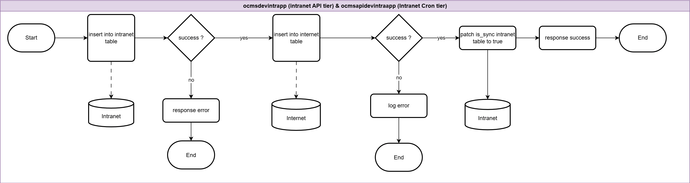

|  |  |  |
| --- | --- | --- |
| **Step** | **Definition** | **Brief Description** |
| Start | Entry point of the process flow | The workflow begins here. |
| Insert into intranet table | Add a new record to the intranet database | Data is inserted into the intranet table for processing. |
| Success? (Intranet insert) | Decision point to check intranet insertion status | Verifies whether the intranet table insert was successful. |
| Response error | Return an error response | If the intranet insert fails, an error response is returned and the process stops. |
| Insert into internet table | Add a new record to the internet database | Data from the intranet is inserted into the internet table. |
| Success? (Internet insert) | Decision point to check internet insertion status | Verifies whether the internet table insert was successful. |
| Log error | Record an error in logs | If the internet insert fails, the error is logged and the process stops. |
| Patch is_sync intranet table to true | Update intranet table record | Marks the record in the intranet table as synchronized. |
| Response success | Return a success response | Indicates successful completion of the synchronization process. |
| End | Exit point of the process flow | The workflow ends here. |











### Data Mapping

#### Notice Table

|  |  |  |
| --- | --- | --- |
| **Zone** | **Database Table** | **Field Name** |
| Intranet | ocms_valid_offence_notice | Refer to OCMS 3, 4 & 5 |
| Intranet | ocms_offence_notice_detail | Refer to OCMS 3, 4 & 5 |
| Internet | eocms_valid_offence_notice | Refer to ocms_valid_offence_notice |

#### Offender Table

|  |  |  |
| --- | --- | --- |
| **Zone** | **Database Table** | **Field Name** |
| Intranet | ocms_offence_notice_owner_driver | Refer to OCMS data dictionary for the data fields within the ONOD table |
| Internet (PII) | eocms_offence_notice_owner_driver | Refer to OCMS data dictionary for the data fields within the eONOD table |

### Success Outcome

1. Data is successfully inserted into the intranet table.
2. Data is successfully inserted into the internet table.
3. The intranet table record is updated with is_sync set to true.
4. A success response is returned to indicate completion.
5. The workflow reaches the End state without triggering any error-handling paths.

### Error Handling

|  |  |  |
| --- | --- | --- |
| **Error Scenario** | **Definition** | **Brief Description** |
| Intranet insert failure | The insert into the intranet table is not successful | Flow goes to response error and then End |
| Internet insert failure | The insert into the internet table is not successful | Flow goes to log error and then End |

## Cron Retry Intranet Push to Internet

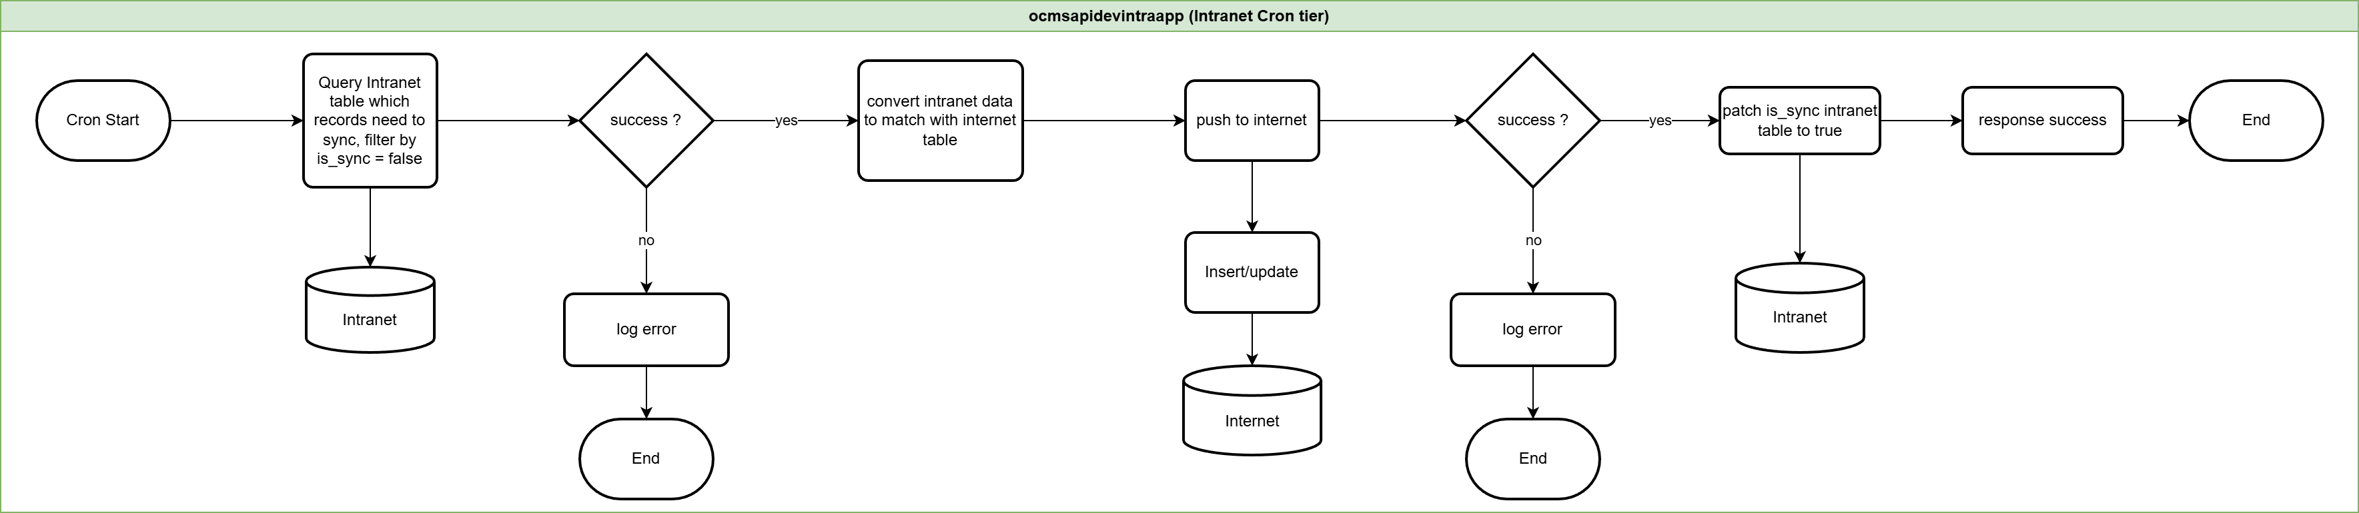

|  |  |  |
| --- | --- | --- |
| **Step** | **Definition** | **Brief Description** |
| Cron Start | Entry point for scheduled execution | The process is triggered by a scheduled cron job. |
| Query intranet table which records need to sync, filter by is_sync = false | Retrieve unsynchronized records from intranet | Reads intranet records where is_sync flag is set to false. |
| Success? (Intranet query) | Decision point to check if query succeeded | Verifies whether the query to fetch unsynced records was successful. |
| Log error | Record error for troubleshooting | Logs details of the failed query into application log for later analysis. |
| Transform & validate for internet schema | Prepare data to match target schema | Remove all fields not inside the internet table; make sure all required fields already have values. |
| Push to internet | Insert or send data to internet database/system | Transfers retrieved intranet records to the internet database.  Insert into the Internet database using insert-only, unique-PK semantics:   * If the PK doesn’t exist → insert the row. * If the PK already exists → treat as update. |
| Success? (Push to internet) | Decision point to check if push succeeded | Verifies whether data transfer to the internet database/system was successful or already exist. |
| Log error | Record error for troubleshooting | Logs details of the failed push into application log for later analysis. |
| Patch is_sync intranet table to true | Update synchronization status | Sets is_sync flag to true in intranet records that were successfully pushed to the internet. |
| Response success | Return a success message | Confirms that synchronization was completed without errors. |
| End | Exit point of the process flow | Marks the termination of the cron job workflow. |











### Data Mapping

Refer to section 1.3.2

### Success Outcome

1. Cron job starts the workflow.
2. Intranet is queried for records where is_sync = false.
3. Records are pushed to the internet.
4. Intranet records are patched with is_sync = true.
5. A success response is returned.
6. The workflow ends without triggering any error path.

### Error Handling

|  |  |  |
| --- | --- | --- |
| **Error Scenario** | **Definition** | **Brief Description** |
| Intranet query failure | The query for records with is_sync = false is not successful | The flow log the error to application log and ends. |
| Push to internet failure | The operation that pushes data to the internet system is not successful | The flow log the error to application log and ends. |

## Intranet Update

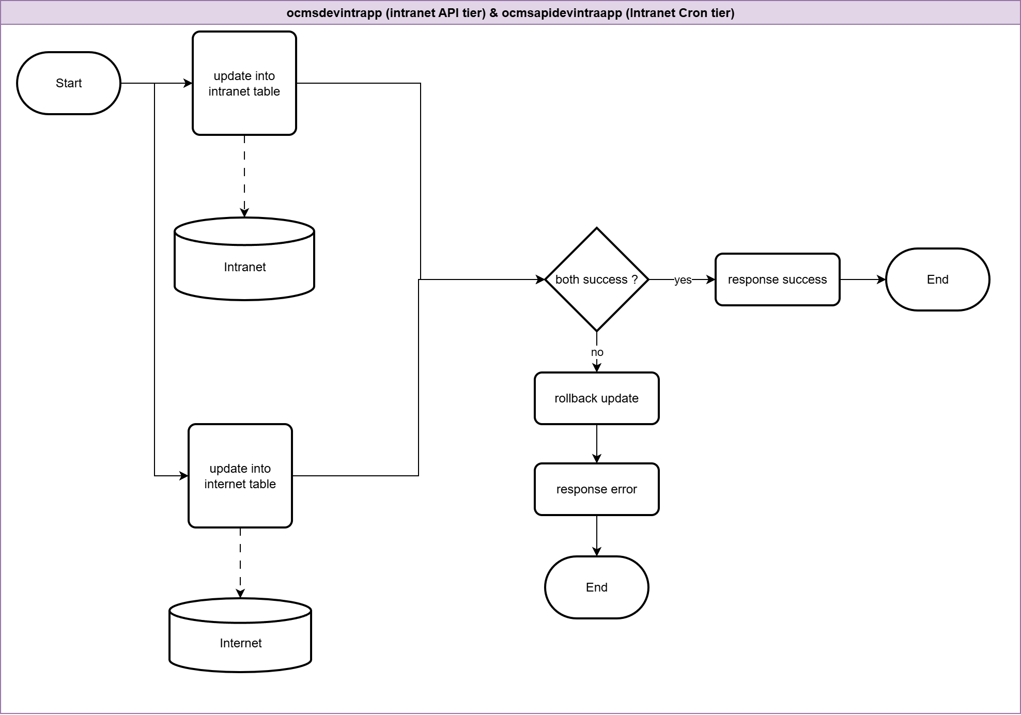

|  |  |  |
| --- | --- | --- |
| **Step** | **Definition** | **Brief Description** |
| Start | Entry point of the process flow | The workflow begins here. |
| Update into intranet table | Update an existing record in the intranet database | Executes an update on the intranet table. |
| Update into internet table | Update an existing record in the internet database | Executes an update on the internet table. |
| Both success? | Decision point to verify update success | Checks if both intranet and internet updates were successful. |
| Response success | Return a success message | Sent if both updates succeed. |
| Rollback update | Reverse the changes made during update | Reverts both intranet and internet updates when either or both fail, ensuring a complete rollback of all related changes. |
| Response error | Return an error message | Sent after rollback to indicate failure. |
| End | Exit point of the process flow | Marks the termination of the process. |











### Data Mapping

#### Offender Table

|  |  |  |
| --- | --- | --- |
| **Zone** | **Database Table** | **Field Name** |
| Intranet | ocms_offence_notice_owner_driver | Refer to OCMS data dictionary for the data fields within the ONOD table |
| Internet (PII) | eocms_offence_notice_owner_driver | Refer to OCMS data dictionary for the data fields within the eONOD table |

### Success Outcome

1. Update into intranet table completes.
2. Update into internet table completes.
3. Both success? evaluates to yes.
4. Response success is returned.
5. Workflow reaches End without entering the rollback path.

### Error Handling

|  |  |  |
| --- | --- | --- |
| **Error Scenario** | **Definition** | **Brief Description** |
| Any update fails | Either the intranet update or the internet update is not successful | Flow goes to rollback update, then response error, then End. |

## End Day Sync Check

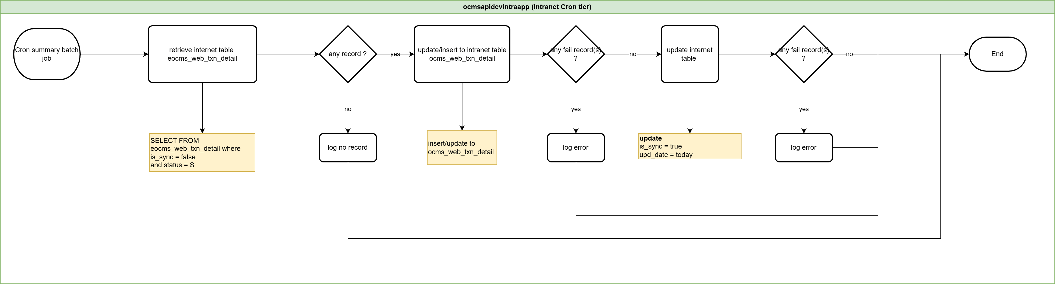

NOTE: Due to page size limit, the full-sized image is appended.



|  |  |  |
| --- | --- | --- |
| **Step** | **Definition** | **Brief Description** |
| Cron summary batch job | Process initiation | The scheduled job triggers the end-day sync process. |
| Retrieve internet table eocms_web_txn_detail | Data extraction | Fetch records from the internet-side transaction table where is_sync = false and status = S. |
| Any record? | Record check | Decision point to verify if eligible records are found. |
| Log no record | No data outcome | If no records exist, log the result and move to status update. |
| Update/insert to intranet table ocms_web_txn_detail | Data sync to intranet | Insert or update the retrieved records into the intranet transaction table. |
| Any fail record(s)? (intranet) | Intranet validation | Check if there are any failed transactions during insert/update to the intranet table. |
| Log error (intranet) | Failure handling | If failures occurred during intranet update, log the error and continue. |
| Update internet table | Data sync confirmation | Update the internet-side transaction table to mark records as synced: is_sync = true, upd_date = today. |
| Any fail record(s)? (internet) | Internet validation | Check if there are any failures during the internet table update. |
| Log error (internet) | Failure handling | If failures occurred during the internet update, log the error and continue. |
| ~~Update status cron in ocms_batch_job~~ | ~~Status update~~ | ~~Update the cron job status in the batch job table regardless of earlier outcomes.~~ |
| Summary batch job report process | Reporting | Generate a summary report of the batch job run (refer to OCMS 7 Technical Document). |



### Data Mapping

#### Intranet Push to Internet

Refer to Section 1.3.1

#### Intranet Pull update from Internet

Refer to Section 4.3.2

### Success Outcome

1. Records retrieved – Eligible transactions (is_sync = false and status = S) are successfully fetched from the internet transaction table.
2. Records synced to intranet – The system successfully inserts or updates the retrieved transactions into the intranet table ocms_web_txn_detail.
3. Internet table updated – The internet transaction table eocms_web_txn_detail is updated with is_sync = true and upd_date = today for all processed records.
4. No sync errors detected – The process confirms that both intranet and internet updates complete without failures.
5. ~~Status updated – The cron job status in ocms_batch_job is successfully updated to reflect the sync completion.~~
6. Summary report generated – A summary batch job report is created, in line with the OCMS 7 Technical Document.
7. Process completed – The end-day sync finishes successfully, with all eligible records synchronized and logged appropriately.

### Error Handling

|  |  |  |
| --- | --- | --- |
| **Error Scenario** | **Definition** | **Brief Description** |
| No record found | No eligible transactions retrieved from eocms_web_txn_detail | When the query returns no rows (is_sync = false and status = S), the process logs “no record” before moving to status update. |
| Intranet update/insert failure | Failure while updating/inserting into ocms_web_txn_detail | If errors occur during the intranet table sync, the process logs the error, then proceeds to the status update step. |
| Internet update failure | Failure while updating eocms_web_txn_detail | If the internet table update (setting is_sync = true and upd_date = today) fails, the error is logged before continuing to the status update step. |



How to monitor and ensure internet and intranet are sync-ed at the end of the day? And be notified if there’s prolong sync failure?

## Scenario Intranet Push to Internet

### Create Notice

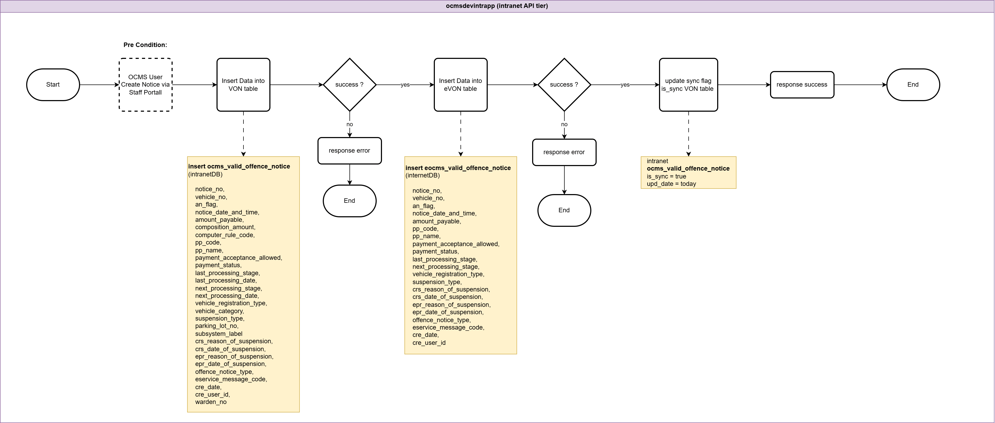

NOTE: Due to page size limit, the full-sized image is appended.



|  |  |  |
| --- | --- | --- |
| **Zone** | **Database Table** | **Field Name** |
| intranet | ocms_valid_offence_notice | notice_no |
| intranet | ocms_valid_offence_notice | vehicle_no |
| intranet | ocms_valid_offence_notice | an_flag |
| intranet | ocms_valid_offence_notice | notice_date_and_time |
| intranet | ocms_valid_offence_notice | amount_payable |
| intranet | ocms_valid_offence_notice | composition_amount |
| intranet | ocms_valid_offence_notice | computer_rule_code |
| intranet | ocms_valid_offence_notice | pp_code |
| intranet | ocms_valid_offence_notice | pp_name |
| intranet | ocms_valid_offence_notice | payment_acceptance_allowed |
| intranet | ocms_valid_offence_notice | payment_status |
| intranet | ocms_valid_offence_notice | last_processing_stage |
| intranet | ocms_valid_offence_notice | last_processing_date |
| intranet | ocms_valid_offence_notice | next_processing_stage |
| intranet | ocms_valid_offence_notice | next_processing_date |
| intranet | ocms_valid_offence_notice | vehicle_registration_type |
| intranet | ocms_valid_offence_notice | vehicle_category |
| intranet | ocms_valid_offence_notice | suspension_type |
| intranet | ocms_valid_offence_notice | parking_lot_no |
| intranet | ocms_valid_offence_notice | subsystem_label |
| intranet | ocms_valid_offence_notice | crs_reason_of_suspension |
| intranet | ocms_valid_offence_notice | crs_date_of_suspension |
| intranet | ocms_valid_offence_notice | epr_reason_of_suspension |
| intranet | ocms_valid_offence_notice | epr_date_of_suspension |
| intranet | ocms_valid_offence_notice | offence_notice_type |
| intranet | ocms_valid_offence_notice | eservice_message_code |
| intranet | ocms_valid_offence_notice | cre_date |
| intranet | ocms_valid_offence_notice | cre_user_id |
| intranet | ocms_valid_offence_notice | warden_no |
| intranet | ocms_valid_offence_notice | is_sync |
| intranet | ocms_valid_offence_notice | upd_date |
| internet | eocms_valid_offence_notice | notice_no |
| internet | eocms_valid_offence_notice | vehicle_no |
| internet | eocms_valid_offence_notice | an_flag |
| internet | eocms_valid_offence_notice | notice_date_and_time |
| internet | eocms_valid_offence_notice | amount_payable |
| internet | eocms_valid_offence_notice | pp_code |
| internet | eocms_valid_offence_notice | pp_name |
| internet | eocms_valid_offence_notice | payment_acceptance_allowed |
| internet | eocms_valid_offence_notice | payment_status |
| internet | eocms_valid_offence_notice | last_processing_stage |
| internet | eocms_valid_offence_notice | next_processing_stage |
| internet | eocms_valid_offence_notice | vehicle_registration_type |
| internet | eocms_valid_offence_notice | suspension_type |
| internet | eocms_valid_offence_notice | crs_reason_of_suspension |
| internet | eocms_valid_offence_notice | crs_date_of_suspension |
| internet | eocms_valid_offence_notice | epr_reason_of_suspension |
| internet | eocms_valid_offence_notice | epr_date_of_suspension |
| internet | eocms_valid_offence_notice | offence_notice_type |
| internet | eocms_valid_offence_notice | eservice_message_code |
| internet | eocms_valid_offence_notice | cre_date |
| internet | eocms_valid_offence_notice | cre_user_id |

### Enquiry and Process LTA

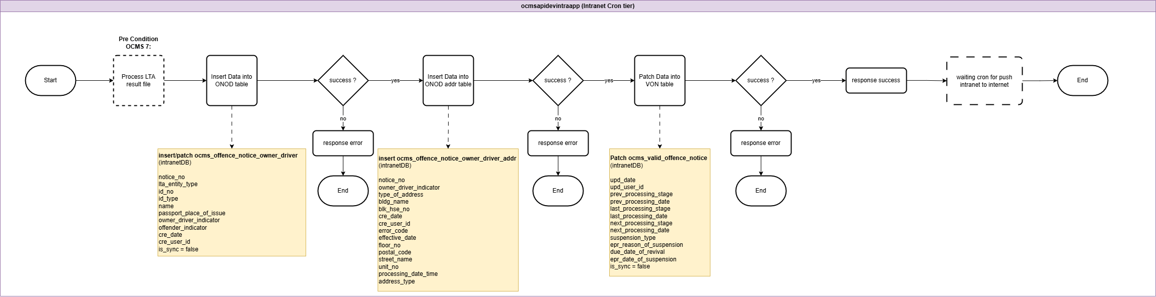

NOTE: Due to page size limit, the full-sized image is appended.



|  |  |  |  |  |  |  |  |
| --- | --- | --- | --- | --- | --- | --- | --- |
| **Zone** | **Database Table** | **Field Name** | | | | | |
| intranet | ocms_offence_notice_owner_driver | notice_no | | | | | |
| intranet | ocms_offence_notice_owner_driver | lta_entity_type | | | | | |
| intranet | ocms_offence_notice_owner_driver | id_no | | | | | |
| intranet | ocms_offence_notice_owner_driver | id_type | | | | | |
| intranet | ocms_offence_notice_owner_driver | name | | | | | |
| intranet | ocms_offence_notice_owner_driver | passport_place_of_issue | | | | | |
| intranet | ocms_offence_notice_owner_driver | owner_driver_indicator | | | | | |
| intranet | ocms_offence_notice_owner_driver | offender_indicator | | | | | |
| intranet | ocms_offence_notice_owner_driver | cre_date | | | | | |
| intranet | ocms_offence_notice_owner_driver | cre_user_id | | | | | |
| intranet | ocms_offence_notice_owner_driver | is_sync | | | | | |
| intranet | ocms_offence_notice_owner_driver_addr | notice_no | | | | | |
| intranet | ocms_offence_notice_owner_driver_addr | owner_driver_indicator | | | | | |
| intranet | ocms_offence_notice_owner_driver_addr | type_of_address | | | | | |
| intranet | ocms_offence_notice_owner_driver_addr | bldg_name | | | | | |
| intranet | ocms_offence_notice_owner_driver_addr | blk_hse_no | | | | | |
| intranet | ocms_offence_notice_owner_driver_addr | cre_date | | | | | |
| intranet | ocms_offence_notice_owner_driver_addr | cre_user_id | | | | | |
| intranet | ocms_offence_notice_owner_driver_addr | error_code | | | | | |
| intranet | ocms_offence_notice_owner_driver_addr | effective_date | | | | | |
| intranet | ocms_offence_notice_owner_driver_addr | floor_no | | | | | |
| intranet | ocms_offence_notice_owner_driver_addr | postal_code | | | | | |
| intranet | ocms_offence_notice_owner_driver_addr | street_name | | | | | |
| intranet | ocms_offence_notice_owner_driver_addr | unit_no | | | | | |
| intranet | ocms_offence_notice_owner_driver_addr | processing_date_time | | | | | |
| intranet | ocms_offence_notice_owner_driver_addr | address_type | | | | | |
| intranet | ocms_valid_offence_notice (patch) | prev_processing_stage | | | | | |
| intranet | ocms_valid_offence_notice (patch) | prev_processing_date | | | | | |
| intranet | ocms_valid_offence_notice (patch) | last_processing_stage | | | | | |
| intranet | ocms_valid_offence_notice (patch) | last_processing_date | | | | | |
| intranet | ocms_valid_offence_notice (patch) | next_processing_stage | | | | | |
| intranet | ocms_valid_offence_notice (patch) | next_processing_date | | | | | |
| intranet | ocms_valid_offence_notice (patch) | suspension_type | | | | | |
| intranet | ocms_valid_offence_notice (patch) | epr_reason_of_suspension | | | | | |
| intranet | ocms_valid_offence_notice (patch) | due_date_of_revival | | | | | |
| intranet | ocms_valid_offence_notice (patch) | epr_date_of_suspension | | | | | |
| intranet | ocms_valid_offence_notice (patch) | upd_date | | | | | |
| intranet | ocms_valid_offence_notice (patch) | upd_user_id | | | | | |
| intranet | ocms_valid_offence_notice (patch) | is_sync | | | | | |
| ~~PII~~ | ~~eocms_offence_notice_owner_driver_addr~~ | ~~type_of_address~~ | | | | | |

### Process MHA result file

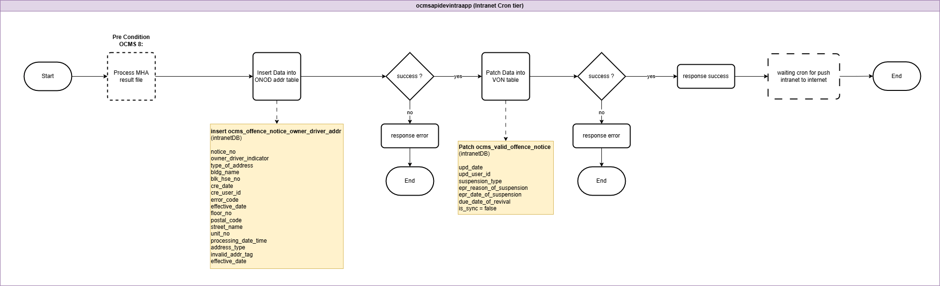

NOTE: Due to page size limit, the full-sized image is appended.



|  |  |  |
| --- | --- | --- |
| **Zone** | **Database Table** | **Field Name** |
| intranet | ocms_offence_notice_owner_driver_addr | notice_no |
| intranet | ocms_offence_notice_owner_driver_addr | owner_driver_indicator |
| intranet | ocms_offence_notice_owner_driver_addr | type_of_address |
| intranet | ocms_offence_notice_owner_driver_addr | bldg_name |
| intranet | ocms_offence_notice_owner_driver_addr | blk_hse_no |
| intranet | ocms_offence_notice_owner_driver_addr | cre_date |
| intranet | ocms_offence_notice_owner_driver_addr | cre_user_id |
| intranet | ocms_offence_notice_owner_driver_addr | error_code |
| intranet | ocms_offence_notice_owner_driver_addr | effective_date |
| intranet | ocms_offence_notice_owner_driver_addr | floor_no |
| intranet | ocms_offence_notice_owner_driver_addr | postal_code |
| intranet | ocms_offence_notice_owner_driver_addr | street_name |
| intranet | ocms_offence_notice_owner_driver_addr | unit_no |
| intranet | ocms_offence_notice_owner_driver_addr | processing_date_time |
| intranet | ocms_offence_notice_owner_driver_addr | address_type |
| intranet | ocms_offence_notice_owner_driver_addr | invalid_addr_tag |
| intranet | ocms_valid_offence_notice (patch) | upd_date |
| intranet | ocms_valid_offence_notice (patch) | upd_user_id |
| intranet | ocms_valid_offence_notice (patch) | suspension_type |
| intranet | ocms_valid_offence_notice (patch) | epr_reason_of_suspension |
| intranet | ocms_valid_offence_notice (patch) | epr_date_of_suspension |
| intranet | ocms_valid_offence_notice (patch) | due_date_of_revival |
| intranet | ocms_valid_offence_notice | is_sync |
| ~~PII~~ | ~~eocms_offence_notice_owner_driver_addr~~ | ~~notice_no~~ |

### Enquiry UEN and FIN DataHive

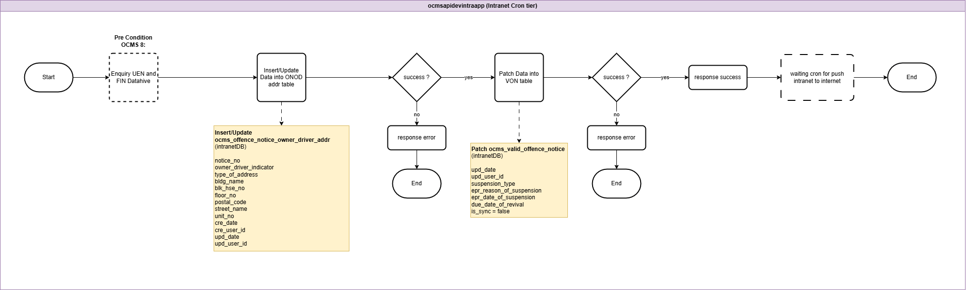

NOTE: Due to page size limit, the full-sized image is appended.



|  |  |  |
| --- | --- | --- |
| **Zone** | **Database Table** | **Field Name** |
| intranet | ocms_offence_notice_owner_driver_addr | notice_no |
| intranet | ocms_offence_notice_owner_driver_addr | owner_driver_indicator |
| intranet | ocms_offence_notice_owner_driver_addr | type_of_address |
| intranet | ocms_offence_notice_owner_driver_addr | bldg_name |
| intranet | ocms_offence_notice_owner_driver_addr | blk_hse_no |
| intranet | ocms_offence_notice_owner_driver_addr | floor_no |
| intranet | ocms_offence_notice_owner_driver_addr | postal_code |
| intranet | ocms_offence_notice_owner_driver_addr | street_name |
| intranet | ocms_offence_notice_owner_driver_addr | unit_no |
| intranet | ocms_offence_notice_owner_driver_addr | cre_date |
| intranet | ocms_offence_notice_owner_driver_addr | cre_user_id |
| intranet | ocms_offence_notice_owner_driver_addr | upd_date |
| intranet | ocms_offence_notice_owner_driver_addr | upd_user_id |
| intranet | ocms_valid_offence_notice (patch) | upd_date |
| intranet | ocms_valid_offence_notice (patch) | upd_user_id |
| intranet | ocms_valid_offence_notice (patch) | suspension_type |
| intranet | ocms_valid_offence_notice (patch) | epr_reason_of_suspension |
| intranet | ocms_valid_offence_notice (patch) | epr_date_of_suspension |
| intranet | ocms_valid_offence_notice (patch) | due_date_of_revival |
| intranet | ocms_valid_offence_notice | is_sync |



### Enquiry Toppan File

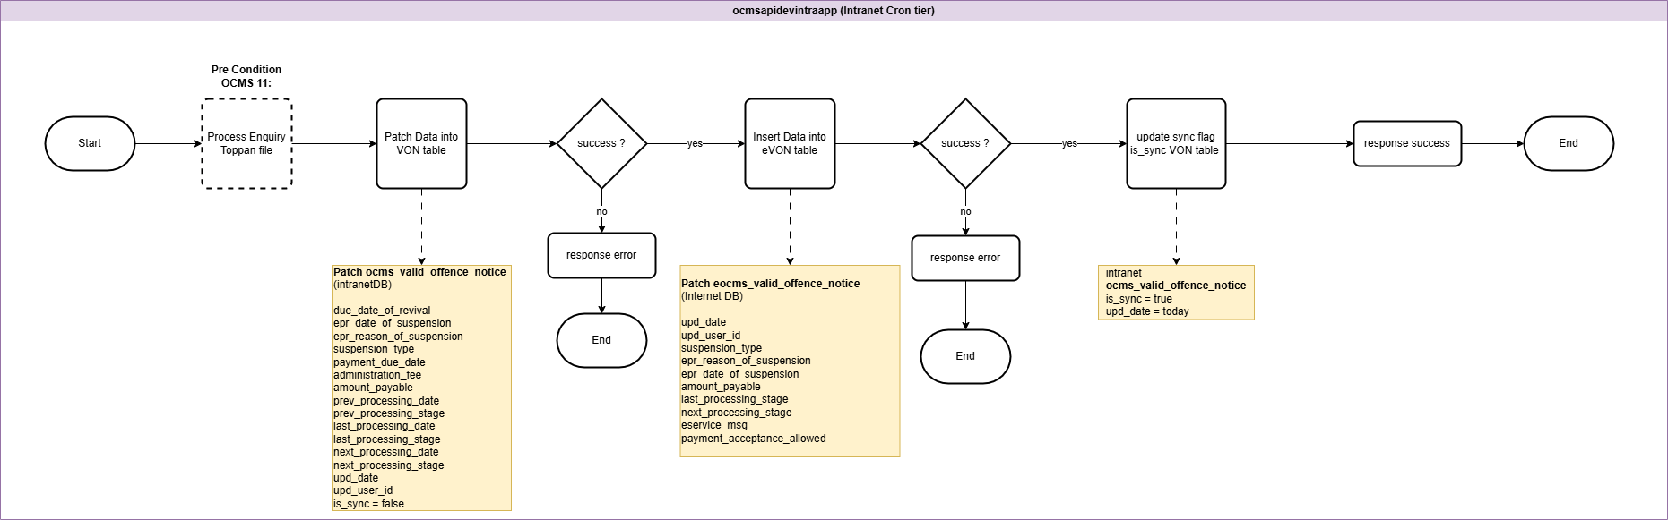

NOTE: Due to page size limit, the full-sized image is appended.



|  |  |  |  |
| --- | --- | --- | --- |
| **Zone** | **Database Table** | | **Field Name** |
| intranet | ocms_valid_offence_notice (patch) | | due_date_of_revival |
| intranet | ocms_valid_offence_notice (patch) | | epr_date_of_suspension |
| intranet | ocms_valid_offence_notice (patch) | | epr_reason_of_suspension |
| intranet | ocms_valid_offence_notice (patch) | | suspension_type |
| intranet | ocms_valid_offence_notice (patch) | | payment_due_date |
| intranet | ocms_valid_offence_notice (patch) | | administration_fee |
| intranet | ocms_valid_offence_notice (patch) | | amount_payable |
| intranet | ocms_valid_offence_notice (patch) | | prev_processing_date |
| intranet | ocms_valid_offence_notice (patch) | | prev_processing_stage |
| intranet | ocms_valid_offence_notice (patch) | | last_processing_date |
| intranet | ocms_valid_offence_notice (patch) | | last_processing_stage |
| intranet | ocms_valid_offence_notice (patch) | | next_processing_date |
| intranet | ocms_valid_offence_notice (patch) | | next_processing_stage |
| intranet | ocms_valid_offence_notice (patch) | | upd_date |
| intranet | ocms_valid_offence_notice (patch) | | upd_user_id |
| intranet | ocms_valid_offence_notice | | is_sync (set true) |
| internet | eocms_valid_offence_notice (patch) | | upd_date |
| internet | eocms_valid_offence_notice (patch) | | upd_user_id |
| internet | eocms_valid_offence_notice (patch) | | suspension_type |
| internet | eocms_valid_offence_notice (patch) | | epr_reason_of_suspension |
| internet | eocms_valid_offence_notice (patch) | | epr_date_of_suspension |
| internet | eocms_valid_offence_notice (patch) | | amount_payable |
| internet | eocms_valid_offence_notice (patch) | | last_processing_stage |
| internet | eocms_valid_offence_notice (patch) | | next_processing_stage |
| internet | | eocms_valid_offence_notice (patch) | eservice_msg |
| internet | | eocms_valid_offence_notice (patch) | payment_acceptance_allowed |

++ what other process will trigger update from intranet to internet? Dayend mass stage change process? Update of payment allowance?

### Cron Push Intranet to Internet



















































































































































































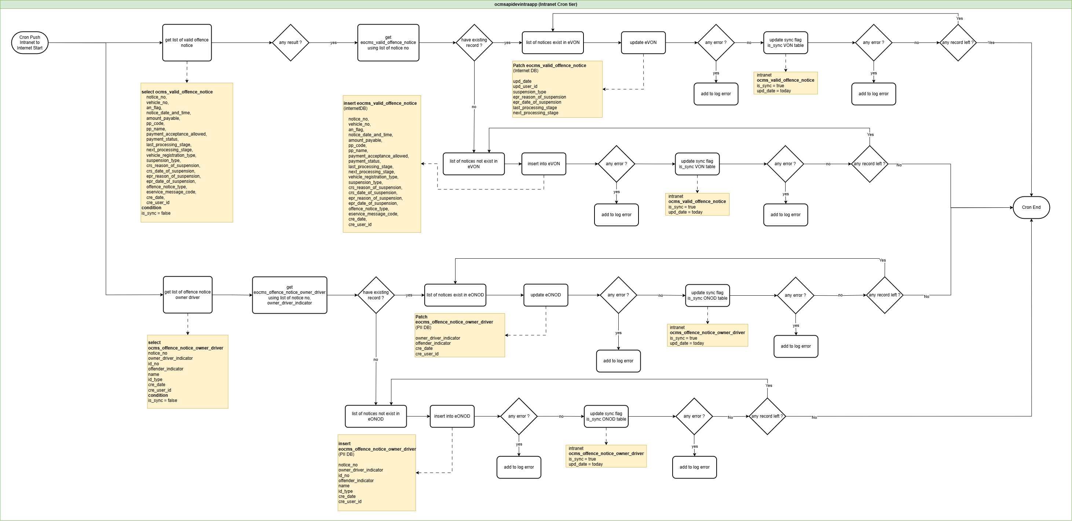

NOTE: Due to page size limit, the full-sized image is appended.



|  |  |  |
| --- | --- | --- |
| **Zone** | **Database Table** | **Field Name** |
| internet | eocms_valid_offence_notice | notice_no |
| internet | eocms_valid_offence_notice | vehicle_no |
| internet | eocms_valid_offence_notice | an_flag |
| internet | eocms_valid_offence_notice | notice_date_and_time |
| internet | eocms_valid_offence_notice | amount_payable |
| internet | eocms_valid_offence_notice | pp_code |
| internet | eocms_valid_offence_notice | pp_name |
| internet | eocms_valid_offence_notice | payment_acceptance_allowed |
| internet | eocms_valid_offence_notice | payment_status |
| internet | eocms_valid_offence_notice | last_processing_stage |
| internet | eocms_valid_offence_notice | next_processing_stage |
| internet | eocms_valid_offence_notice | vehicle_registration_type |
| internet | eocms_valid_offence_notice | suspension_type |
| internet | eocms_valid_offence_notice | crs_reason_of_suspension |
| internet | eocms_valid_offence_notice | crs_date_of_suspension |
| internet | eocms_valid_offence_notice | epr_reason_of_suspension |
| internet | eocms_valid_offence_notice | epr_date_of_suspension |
| internet | eocms_valid_offence_notice | offence_notice_type |
| internet | eocms_valid_offence_notice | eservice_message_code |
| internet | eocms_valid_offence_notice | cre_date |
| internet | eocms_valid_offence_notice | cre_user_id |
| intranet | ocms_valid_offence_notice | is_sync (set true) |
| intranet | ocms_valid_offence_notice | upd_date |
| internet | eocms_valid_offence_notice (patch) | upd_date |
| internet | eocms_valid_offence_notice (patch) | upd_user_id |
| internet | eocms_valid_offence_notice (patch) | suspension_type |
| internet | eocms_valid_offence_notice (patch) | epr_reason_of_suspension |
| internet | eocms_valid_offence_notice (patch) | epr_date_of_suspension |
| internet | eocms_valid_offence_notice (patch) | last_processing_stage |
| internet | eocms_valid_offence_notice (patch) | next_processing_stage |
| Internet | eocms_offence_notice_owner_driver (patch) | owner_driver_indicator |
| Internet | eocms_offence_notice_owner_driver (patch) | offender_indicator |
| Internet | eocms_offence_notice_owner_driver (patch) | cre_date |
| Internet | eocms_offence_notice_owner_driver (patch) | cre_user_id |
| Internet | eocms_offence_notice_owner_driver | notice_no |
| Internet | eocms_offence_notice_owner_driver | owner_driver_indicator |
| Internet | eocms_offence_notice_owner_driver | id_no |
| Internet | eocms_offence_notice_owner_driver | offender_indicator |
| Internet | eocms_offence_notice_owner_driver | name |
| Internet | eocms_offence_notice_owner_driver | id_type |
| Internet | eocms_offence_notice_owner_driver | cre_date |
| Internet | eocms_offence_notice_owner_driver | cre_user_id |
| Intranet | ocms_offence_notice_owner_driver | is_sync (set true) |
| Intranet | ocms_offence_notice_owner_driver | upd_date |

# Section 2 – Update payment status from Internet to Intranet

## Use Case

1. When a notice is successfully paid via the eService or AXS:
   1. OCMS updates the notice’s payment status in the Internet database
   2. OCMS records the transaction details (e.g. payment date/time, method, and receipt number) in the Internet database
2. The updated payment status and transaction details in the Internet are then synchronized to the Intranet database to keep the data in both environments aligned.
3. The OCMS Internet backend will send the payment status update to the Intranet via cron in Intranet backend.
4. During processing of the data retrieved from the Internet database, the OCMS Intranet backend will:
   1. Verify that the notice details from the Internet match the corresponding notice in the Intranet
   2. Update the Intranet Notice’s payment status in the Intranet after successful validation
   3. Permanently suspend the Intranet Notice if it is fully paid/partially paid

## High Level Flow

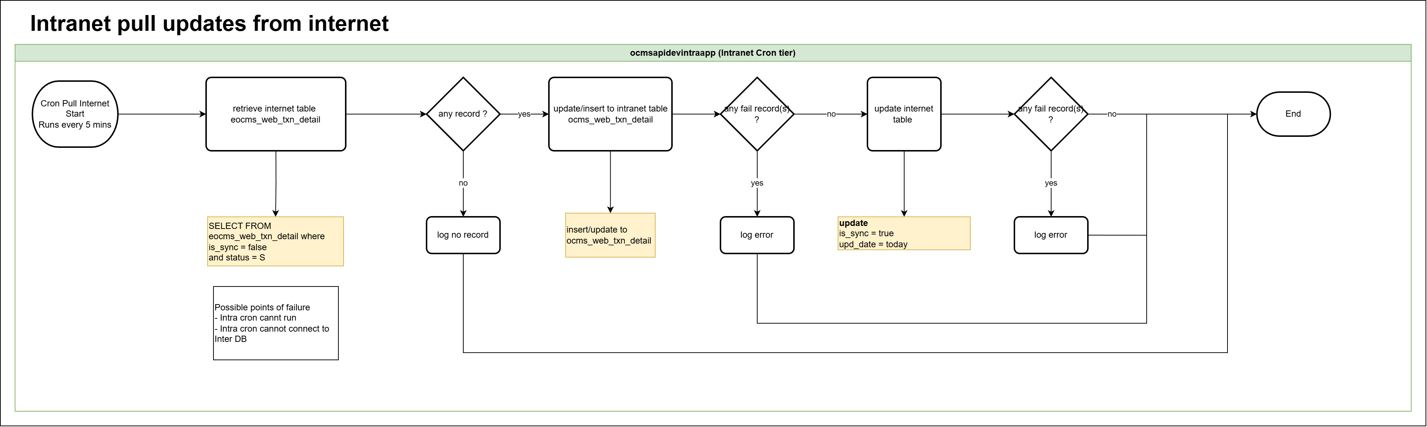

NOTE: Due to page size limit, the full-sized image is appended.



|  |  |  |
| --- | --- | --- |
| **Step** | **Definition** | **Brief Description** |
| Cron Pull Internet Start | Process initiation | The cron job is triggered every 5 minutes to start pulling updates from the internet. |
| Retrieve internet table eocms_web_txn_detail | Data retrieval | The system queries the internet table for records where is_sync = false and status = S. |
| Any record? | Decision point | Checks if the query retrieved any records. If no records exist, log “no record” and end the process. If records exist, continue. |
| Update/insert to intranet table ocms_web_txn_detail | Data synchronization | Records from the internet table are inserted or updated into the intranet table. |
| Any fail record(s)? (after intranet update) | Decision point | Verifies if there are any failed records during the update/insert process. If failures occur, log an error. If none, continue. |
| Update internet table | Status update | Updates the internet table by setting is_sync = true and upd_date = today for successfully processed records. |
| Any fail record(s)? (after internet update) | Decision point | Checks again if any errors occurred while updating the internet table. If yes, log an error. If no, continue. |
| ~~Update status cron in ocms_batch_job~~ | ~~Process tracking~~ | ~~Updates the status of the cron job in the intranet batch job tracking table ocms_batch_job.~~ |
| End | Completion | The process ends after updating the cron status. |















## Intranet pull Internet Update

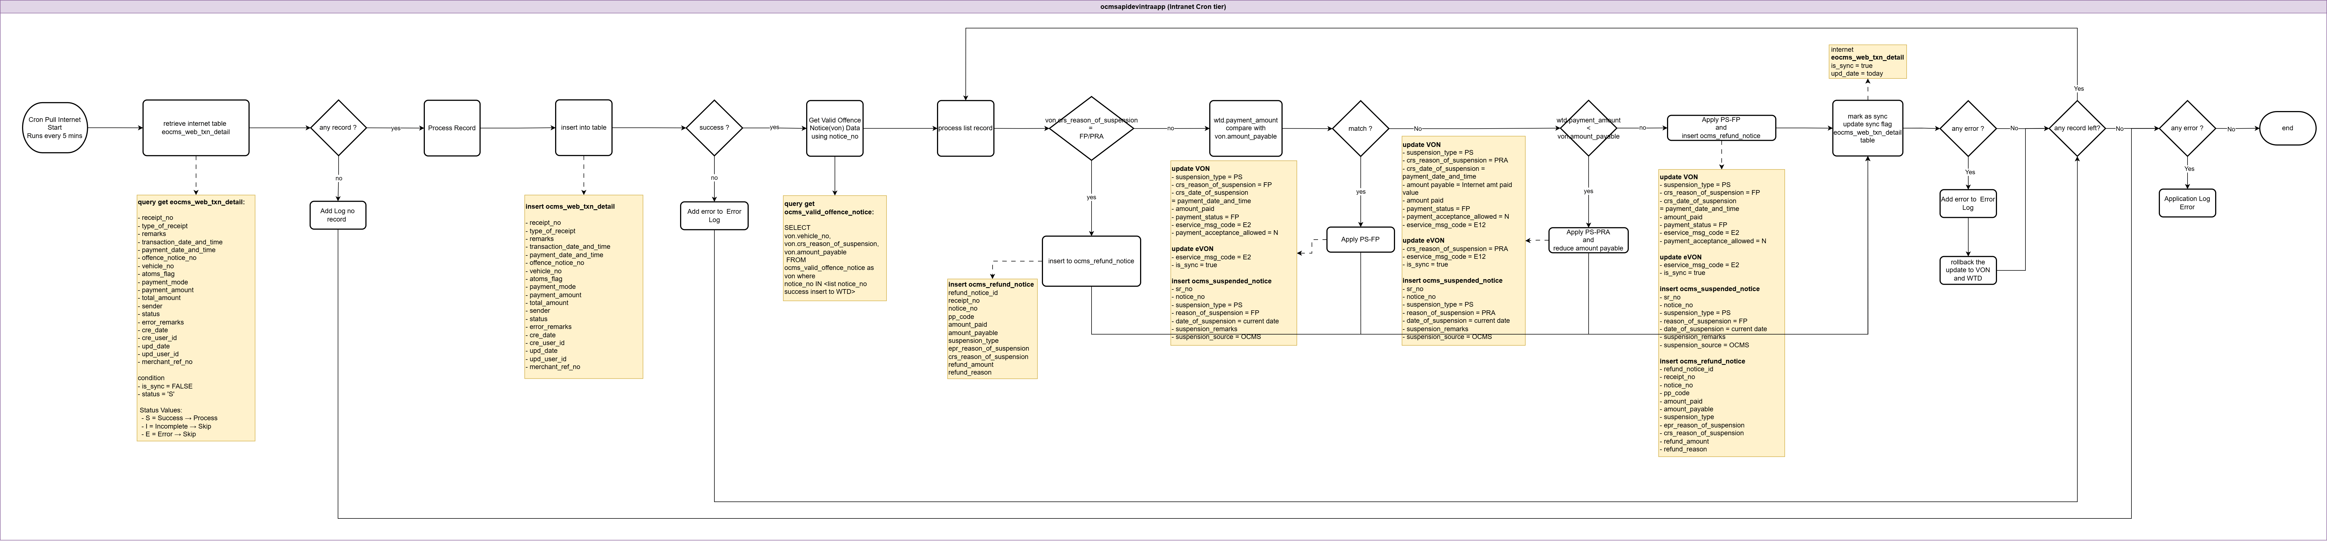

NOTE: Due to page size limit, the full-sized image is appended.



|  |  |  |  |  |  |  |  |  |  |  |  |  |  |  |  |
| --- | --- | --- | --- | --- | --- | --- | --- | --- | --- | --- | --- | --- | --- | --- | --- |
| **Step** | | | | | | | | | **Definition** | | | | **Brief Description** | | |
| Cron Pull Internet Start — Runs every 5 mins | | | | | | | | | Start | | | | Starts the job on a 5-minute schedule. | | |
| retrieve internet table eocms_web_txn_detail | | | | | | | | | Process | | | | Retrieve internet transactions from eocms_web_txn_detail. | | |
| SELECT FROM eocms_web_txn_detail where is_sync = false and status = S | | | | | | | | | Note | | | | Query criteria for pulling unsynced, status S records. | | |
| any record ? | | | | | | | | | Decision | | | | Checks if any rows match the selection criteria. | | |
| log no record | | | | | | | | | Process | | | | Logs “no record” when none are found. | | |
| insert into table | | | | | | | | | Process | | | | insert records. (Dashed link points to intranet DB table.) | | |
| intranet DB — ocms_web_txn_detail | | | | | | | | | Data Store | | | | Target intranet table referenced by dashed connector. | | |
| success ? | | | | | | | | | Decision | | | | Verifies whether the update/insert succeeded. | | |
| log error | | | | | | | | | Process | | | | Logs an error when update/insert fails. | | |
| end | | | | | | | | | Terminator | | | | Flow ends after error logging. | | |
| query VON using notice_no | | | | | | | | | Process | | | | Fetch VON using notice_no. | | |
| ~~vehicle_no match ?~~ | | | | | | | | | ~~Decision~~ | | | | ~~Determines if vehicle numbers match.~~ | | |
| von.crs_reason_of_suspension = FP | | | | | | | | | Decision | | | | Checks if VON reason of suspension equals FP / PRA. | | |
| ~~update refund identified date~~ | | | | | | | | | ~~Process~~ | | | | ~~Updates refund identified date when condition is met.~~ | | |
| ~~update VON and eVONinsert to ocms_refund_notice~~ | | | | | | | | | ~~Note~~ | | | | ~~refund_identified_date = current_date~~  ~~payment_status = RE.insert notice_no~~ | | |
| internet — eocms_web_txn_detail — is_sync = true — end | | | | | | | | | Terminator | | | | Flow ends after refund identification update. | | |
| wtd.payment_amount compare with von.amount_payable | | | | | | | | | Process | | | | Compares WTD payment amount with VON amount payable. | | |
| match ? | | | | | | | | | Decision | | | | Checks if amounts match. | | |
| Apply PS-FP | | | | | | | | | Process | | | | Applies PS-FP path when amounts match. | | |
| update VON & eVON | | | | | | | | | Note | | | | VON  suspension_type = PS  crs_reason_of_suspension = FP  crs_date_of_suspension = payment_date_and_time  amount_paid  payment_status = FP  eservice_msg_code = E2  payment_acceptance_allowed = N  eVON  - eservice_msg_code = E2  - is_sync = true | | |
| insert ocms_suspended_notice | | | | | | | | | Note | | | | sr_no  notice_no  suspension_type = PS  reason_of_suspension = FP  date_of_suspension = current date  suspension_remarks  suspension_source = OCMS. | | |
| internet — eocms_web_txn_detail — is_sync = true — Eend | | | | | | | | | Terminator | | | | Flow ends for PS-FP (match) branch. | | |
| wtd.payment_amount < von.amount_payable | | | | | | | | | Decision | | | | Amount comparison when not equal. | | |
| Apply PS-PRA and reduce amount payable | | | | | | | | | Process | | | | Applies PS-PRA path and reduces amount payable. | | |
| update VON & eVON | | | | | | | | | Note | | | | VON  suspension_type = PS  crs_reason_of_suspension = PRA  crs_date_of_suspension = payment_date_and_time  amount payable = Internet amt paid value  amount paid  payment_status = FP  payment_acceptance_allowed = N  eservice_msg_code = E12  eVON  crs_reason_of_suspension = PRA  eservice_msg_code = E12  is_sync = true | | |
| insert ocms_suspended_notice | | | | | | | | | Note | | | | sr_no  notice_no  suspension_type = PS  reason_of_suspension = PRA  date_of_suspension = current date  suspension_remarks  suspension_source = OCMS. | | |
| internet — eocms_web_txn_detail — is_sync = true — End | | | | | | | | | Terminator | | | | Flow ends for PS-PRA branch. | | |
| Apply PS-FP and insert ocms_refund notice | | | | | | | | | Process | | | | Applies PS-FP and insert to ocms_refund_notice when amount is not less. | | |
| update VON & eVON | | | | | | | | | Note | | | | VON  suspension_type = PS  crs_reason_of_suspension = FP  crs_date_of_suspension = payment_date_and_time  amount_paid  payment_status = FP  eservice_msg_code = E2  payment_acceptance_allowed = N  eVON  eservice_msg_code = E2  is_sync = true | | |
| insert ocms_suspended_notice | | | | | | | | | Note | | | | sr_no  notice_no  suspension_type = PS  reason_of_suspension = FP  date_of_suspension = current date  suspension_remarks  suspension_source = OCMS. | | |
| any error ? | | | | | | | | | Decision | | | | Error check following. | | |
| log error | | | | | | | | | Process | | | | Logs error when present. | | |
| rollback update | | | | | | | | | Process | | | | Rollback the update VON and WTD when there is an error | | |
| check record left | Process | | If yes, back to check other record.  If no, continue | | | | | | | | |
| any error ? | Decision | | Error check following. | | | | | | | | |
| log error | Process | | Logs error when present. | | | | | | | | |
| end | | | | | | | | | Terminator | | | | Flow ends after final update/insert. | | |











### Data Mapping

#### Insert transaction payment status

|  |  |  |  |
| --- | --- | --- | --- |
| **Zone** | **Database Table** | **Field Name** | **Description** |
| intranet | ocms_web_txn_detail | receipt_no | TxnId |
| intranet | ocms_web_txn_detail | mercant_ref_no | TxnRef |
| intranet | ocms_web_txn_detail | remarks | ResponseMsg |
| intranet | ocms_web_txn_detail | transaction_date_and_time | Date + time |
| intranet | ocms_web_txn_detail | payment_date_and_time | Date + time |
| intranet | ocms_web_txn_detail | payment_mode | ENETC/PYNOW/JX |
| intranet | ocms_web_txn_detail | payment_amount | AmtTransacted |
| intranet | ocms_web_txn_detail | total_amount | Sum AmtTransacted |
| intranet | ocms_web_txn_detail | status | S |
| intranet | ocms_web_txn_detail | offence_notice_no |  |
| intranet | ocms_web_txn_detail | vehicle_no |  |
| Intranet | ocms_web_txn_detail | sender | UOL/AXS |
| internet | eocms_web_txn_detail | is_sync | true (sync success) |

#### Update payment status to Main Table

|  |  |  |  |
| --- | --- | --- | --- |
| **Zone** | **Database Table** | **Field Name** | **Description** |
| intranet | ocms_valid_offence_notice | suspension_type | PS |
| intranet | ocms_valid_offence_notice | crs_reason_of_suspension | PRA/FP |
| intranet | ocms_valid_offence_notice | crs_date_of_suspension | wtd.payment_date_and_time |
| Intranet | ocms_valid_offence_notice | amount_paid | wtd.payment_amount |
| Intranet | ocms_valid_offence_notice | payment_status | FP |
| Intranet | ocms_valid_offence_notice | eservice_msg_code | E2/E12 |
| Intranet | ocms_valid_offence_notice | payment_acceptance_allowed | N |
| Intranet | eocms_valid_offence_notice | is_sync | true |
| internet | eocms_valid_offence_notice | eservice_msg_code | E2/E12 |
| internet | eocms_valid_offence_notice | crs_reason_of_suspension | PRA |
| intranet | ocms_suspended_notice | sr_no | Generated sequence number |
| intranet | ocms_suspended_notice | notice_no |  |
| intranet | ocms_suspended_notice | suspension_type | PS |
| intranet | ocms_suspended_notice | reason_of_suspension | FP/PRA |
| intranet | ocms_suspended_notice | date_of_sesupension | Current date |
| intranet | ocms_suspended_notice | suspension_remarks |  |
| intranet | ocms_suspended_notice | suspension_source | OCMS code |

#### Insert Refund Notice

|  |  |  |  |
| --- | --- | --- | --- |
| **Zone** | **Database Table** | **field name** | **Description** |
| intranet | ocms_refund_notice | notice_no | VON.notice_no |
| intranet | ocms_refund_notice | refund_notice_id |  |
| intranet | ocms_refund_notice | receipt_no | WTD.receipt_no |
| intranet | ocms_refund_notice | pp_code | VON.pp_code |
| intranet | ocms_refund_notice | amount_paid | VON.amount_paid |
| intranet | ocms_refund_notice | amount_payable | VON.amount_payable |
| intranet | ocms_refund_notice | suspension_type | VON.suspension_type |
| intranet | ocms_refund_notice | crs_reason_of_suspension | VON.crs_reason_of_suspension |
| intranet | ocms_refund_notice | epr_reason_of_suspension | VON.epr_reason_of_suspension |
| intranet | ocms_refund_notice | refund_amount |  |
| intranet | ocms_refund_notice | refund_reason | DBP (double pay) / OVP (over pay) / APP (appeal waiver) |

### Success Outcome

* 1. sync from Internet table to Intranet table without errors.
  2. Vehicle number mismatch handled via suspension update, record insertion and sync marked complete.
  3. Refund identified, recorded successfully and sync marked complete.
  4. Payment amount matches, suspension update completed successfully and and sync marked complete.
  5. Payment amount less than payable, amount adjusted, suspension update completed successfully and sync marked complete.
  6. Payment amount not less, refund identified, final update applied, and sync marked complete.

### Error Handling

|  |  |  |
| --- | --- | --- |
| **Error Scenario** | **Definition** | **Brief Description** |
| Update/Insert Failure (initial sync) | success ? = no after update/insert into table | Write log error and terminate the flow. |
| Processing Error | any error ? = yes after compare vehicle no and match payment amount | Write log error and terminate the flow. |

# 



















# Section 3 – Generate Daily Exception Summary Report for Paid Notices

## Use Case

* + - 1. OCMS generates a daily end-of-day report on payment exceptions from the previous day.
      2. The report lists Intranet Notices that encountered the following exceptions during the processing of payment updates from the Internet database:

|  |  |
| --- | --- |
| **Exception Type** | **Scenario** |
| Notice was suspended with PS-PRA | Notice was partially paid. |
| Notice was suspended with TS-PAM | The vehicle number in the Internet Notice does not match the Intranet Notice. |
| Double Payment | A second payment was made after the notice was already fully paid. |
| Over Payment | The amount paid exceeds the amount payable. |

* + - 1. A scheduled cron service will generate the report daily, including Sundays and public holidays.

* + - 1. The report will be emailed to authorised Fine Processing Officers to notify them of the exceptions so that they can follow up on the Notices.
      2. When there are no exceptions, OCMS will send the report with the remark "No exception records".

## Diagram Flow Image

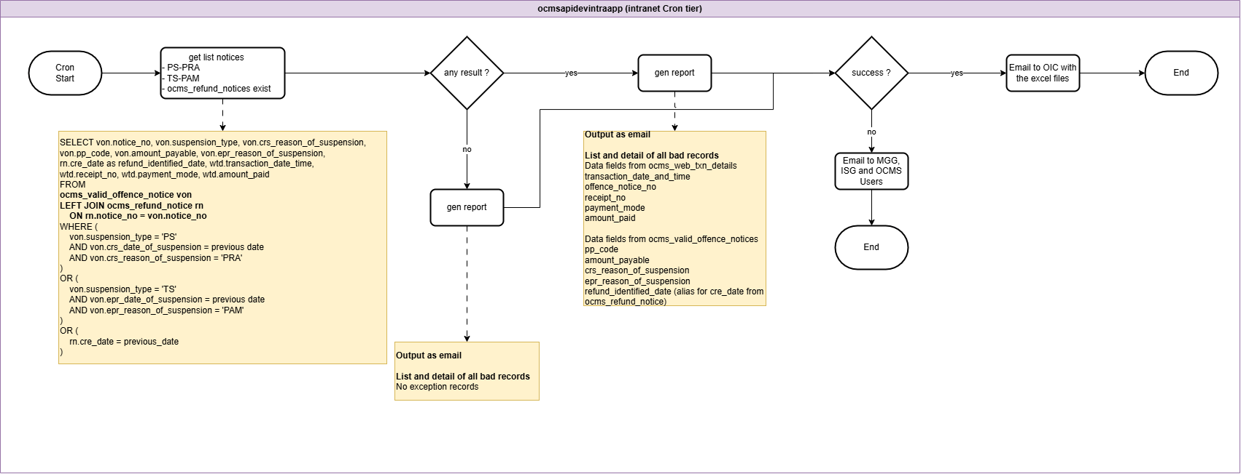

NOTE: Due to page size limit, the full-sized image is appended.



|  |  |  |
| --- | --- | --- |
| **Step** | **Definition** | **Brief Description** |
| Cron Start | Scheduled job initiation | Starts the automated daily process in the intranet Cron tier. |
| Get list notices | Retrieve eligible notices | Fetches notices with categories PS–PRA, TS–PAM, or with exist in ocms_refund_notice present, using the provided SQL query. |
| Any result? | Decision point for data presence | Checks if any records match the selection criteria. |
| Generate report – exception records | Compile exception details | Creates a report listing and detailing all bad records, pulling specified fields from ocms_web_txn_details, ocms_valid_offence_notice and ocms_refund_notice. |
| Generate report – no exception records | Compile empty report | Creates a report stating “No exception records” when no matching data is found. |
| Success? | Verify email template generation | Confirms that the report email template was successfully created. |
| Email to OIC with Excel files | Dispatch results to OIC | Sends the generated report with Excel attachments to the OIC. |
| Email to OIC, MGG, ISG, and OCMS Users | Notify on failure | Sends an email to OIC, MGG, ISG, and OCMS Users if email template generation fails. |
| End | Terminate process | Ends the flow after emails are sent. |











### Data Mapping

#### Email Summary Report

|  |  |  |  |
| --- | --- | --- | --- |
| **Zone** | **Database Table** | **Field Name** | **Report Field Name** |
| Intranet | ocms_web_txn_detail | transaction_date_time | Transaction Date/Time |
| Intranet | ocms_web_txn_detail | receipt_no | Receipt No. |
| Intranet | ocms_web_txn_detail | merchant_ref_no | Transaction ID |
| Intranet | ocms_web_txn_detail | payment_mode | Payment Channel |
| Intranet | ocms_web_txn_detail | payment_amount | Amount Paid |
| Intranet | ocms_web_txn_detail | offence_notice_no | Notice No. |
| Intranet | ocms_valid_offence_notice | crs_reason_of_suspension | Exception Type |
| Intranet | ocms_valid_offence_notice | epr_reason_of_suspension | Exception Type |

### Success Outcome

* + - * 1. generated, and the email template is built successfully.
        2. No exception records are found, a “no exception” report is generated, and the email template is built successfully.
        3. In either outcome above, the email is successfully sent to the OIC with the report in Excel format.

### Error Handling

|  |  |  |
| --- | --- | --- |
| **Error Scenario** | **Definition** | **Brief Description** |
| Email template generation failure | Occurs when the system cannot successfully build the report email template, regardless of whether exceptions exist or not. | Sends a failure notification email to OIC, MGG, ISG, and OCMS Users, then terminates the process. |

# Section 4 – Generate Paid Notices Report for URA Finance

## Use Case

OCMS generates a monthly report with detail of the parking notices that have been paid in the past month.

The report lists all Notices that have been updated as paid via the following channels:

* 1. OCMS Pay Parking Fines eSevice
  2. AXS
  3. OCMS Staff Portal manual update for offline payment methods such as cash and cheque

The report will also list all notices that require refund.

A scheduled cron service will generate the report on the first calendar day of each month, including Sundays and public holidays.

The report will be emailed to authorised URA Finance Officers so that they can keep track of the monthly collections of parking offence notices at other agencies’ car parks (eg. JTC and MND).

## Diagram Flow Image

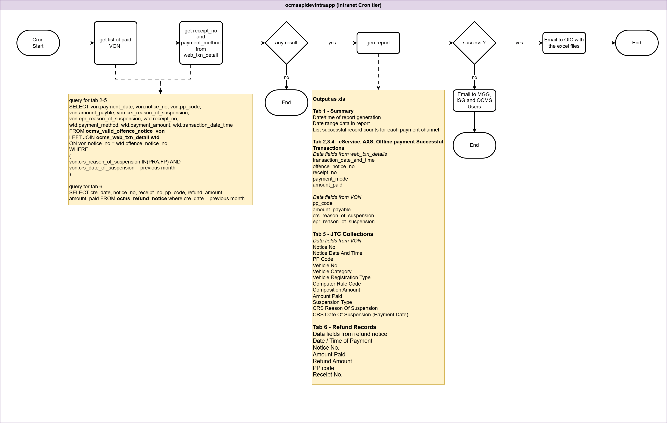

NOTE: Due to page size limit, the full-sized image is appended.



|  |  |  |
| --- | --- | --- |
| **Step** | **Definition** | **Brief Description** |
| Cron Start | Initiate automated process | The process begins with a scheduled cron job under the intranet cron tier (ocmsapidevintraapp). |
| Get List of Paid VON | Fetch eligible paid notices | Retrieves a list of paid VONs (Vehicle Offence Notices) with crs_reason_of_suspension as PRA or FP and suspension date from the previous month. |
| Get Receipt No and Payment Method | Retrieve payment info from transaction table | Extracts receipt_no and payment_method fields by joining ocms_valid_offence_notice with ocms_web_txn_detail using notice_no. |
| Any Result? | Check if any records matched | Verifies if any data was returned from the query; if no results, the flow ends. |
| Generate Report | Compile report into Excel format | Creates an XLS report containing both a summary and a detailed list of successful payment records. |
| Output as XLS | Structure the report content | The report includes:  Tab 1 - Summary  Date/time of report generation  Date range data in report  List successful record counts for each payment channel  Tab 2,3,4 - eService, AXS, Offline payment Successful Transactions  Data fields from web_txn_details  transaction_date_and_time  offence_notice_no  receipt_no  payment_mode  amount_paid  Data fields from VON  pp_code  amount_payable  crs_reason_of_suspension  epr_reason_of_suspension  Tab 5 - JTC Collections  Data fields from VON  Notice No  Notice Date And Time  PP Code  Vehicle No  Vehicle Category  Vehicle Registration Type  Computer Rule Code  Composition Amount  Amount Paid  Suspension Type  CRS Reason Of Suspension  CRS Date Of Suspension (Payment Date)  Tab 6 - Refund Records  Data fields from refund notice  Date / Time of Payment  Notice No.  Amount Paid  Refund Amount  Receipt No. |
| Success? | Confirm report generation | Checks if the Excel file was generated successfully. |
| Email to OIC with the Excel Files | Send report to Officer-in-Charge | If successful, the Excel file is emailed to the Officer-in-Charge. |
| Email to MGG, ISG, and OCMS Users (on failure) | Notify key teams on failure | If report generation fails, an error notification is sent to MGG, ISG, and OCMS users. |
| End | Terminate flow | Ends the cron job after either a successful or failed attempt. |











### Data Mapping

#### Excel Mapping

|  |  |  |  |
| --- | --- | --- | --- |
| **Zone** | **Database Table** | **Field Name** | **Report Field Name** |
| Intranet | ocms_web_txn_detail | transaction_date_time | Date / Time of Payment |
| Intranet | ocms_web_txn_detail | receipt_no | Receipt No. |
| Intranet | ocms_web_txn_detail | payment_mode | Payment Mode |
| Intranet | ocms_web_txn_detail | payment_amount | Payment Amount |
| Intranet | ocms_valid_offence_notice | notice_no | Notice No. |
| Intranet | ocms_valid_offence_notice | notice_date_and_time | Notice Date and Time |
| Intranet | ocms_valid_offence_notice | vehicle_category | Vehicle Category |
| Intranet | ocms_valid_offence_notice | vehicle_registration_type | Vehicle Registration Type |
| Intranet | ocms_valid_offence_notice | vehicle_no | Vehicle No |
| Intranet | ocms_valid_offence_notice | crs_reason_of_suspension | CRS Reason of Suspension |
| Intranet | ocms_valid_offence_notice | epr_reason_of_suspension | EPR Reason of Suspension |
| Intranet | ocms_valid_offence_notice | amount_payable | Amount Payable |
| Intranet | ocms_valid_offence_notice | pp_code | PP code |
| Intranet | ocms_valid_offence_notice | computer_rule_code | Computer Rule Code |
| Intranet | ocms_valid_offence_notice | composition_amount | Composition Amount |
| Intranet | ocms_valid_offence_notice | amount_paid | Amount Paid |
| Intranet | ocms_valid_offence_notice | suspension_type | Suspension Type |
| Intranet | ocms_valid_offence_notice | crs_date_of_suspension | CRS Date Of Suspension (Payment Date) |
| Intranet | ocms_refund_notice | refund_amount | Refund Amount |

### Success Outcome

Eligible paid VONs are found → the Excel report (with the defined tabs and fields) is generated successfully → emailed to the OIC.

No eligible records are found → the process ends without generating a report (per the “Any Result? = No” branch).

### Error Handling

|  |  |  |
| --- | --- | --- |
| **Error Scenario** | **Definition** | **Brief Description** |
| Report generation failure | The Excel file cannot be created during the “Generate Report” step. | Send an error notification email to MGG, ISG, and OCMS Users; then end the process. |